**// 11.1**

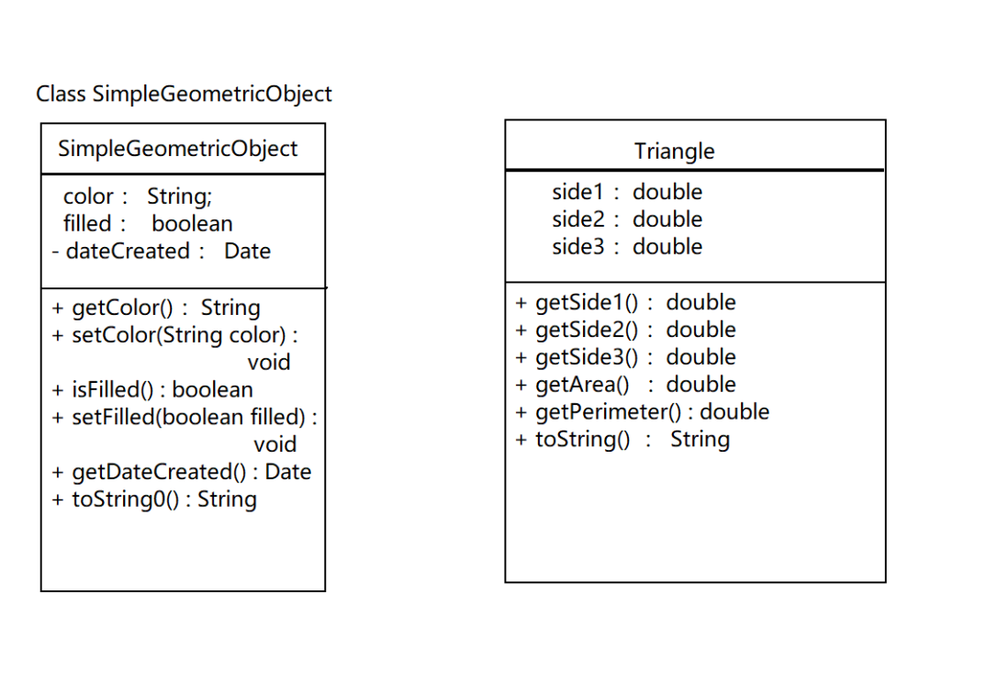

**package JavaClass.Section11**;  
  
**import java.util.Date**;  
**import java.util.Scanner**;  
  
**class SimpleGeometricObject** *{* **String** color = "white";  
 **boolean** filled;  
 **private Date** dateCreated;  
  
 **public** SimpleGeometricObject*() {* dateCreated = **new** Date*()*;  
 *}* **public** SimpleGeometricObject*(***String** color, **boolean** filled*) {* dateCreated = **new** Date*()*;  
 **this**.color = color;  
 **this**.filled = filled;  
 *}* **public String** getColor*() {* **return** color;  
 *}* **public void** setColor*(***String** color*) {* **this**.color = color;  
 *}* **public boolean** isFilled*() {* **return** filled;  
 *}* **public void** setFilled*(***boolean** filled*) {* **this**.filled = filled;  
 *}* **public Date** getDateCreated*() {* **return** dateCreated;  
 *}* **public String** toString0*() {* **return** "created on" + dateCreated + "\ncolor: " + color +  
 " and filled: " + filled;  
 *}  
}***class Triangle extends SimpleGeometricObject** *{* **double** side1 = 1.0;  
 **double** side2 = 1.0;  
 **double** side3 = 1.0;  
  
 **public** Triangle*() { }* **public** Triangle*(***double** side1,**double** side2,**double** side3,**String** color,**boolean** filled*) {* **this**.side1 = side1;  
 **this**.side2 = side2;  
 **this**.side3 = side3;  
 setColor*(*color*)*;  
 setFilled*(*filled*)*;  
 *}* **public double** getSide1*() {* **return** side1;  
 *}* **public double** getSide2*() {* **return** side2;  
 *}* **public double** getSide3*() {* **return** side3;  
 *}* **public double** getArea*() {* **return** side1 * side2 * side3;  
 *}* **public double** getPerimeter*() {* **return** side1 + side2 + side3;  
 *}* **public String** toString*() {* **return** "created on side is " + side1 + " " + side2 +  
 " " + side3 + "\nArea is " + getArea*()* +  
 "\nPerimeter is " + getPerimeter*()*;  
 *}  
}***public class TriangleFromSimpleGeometricObject** *{* **public static void** main*(***String***[]* args*) {* **SimpleGeometricObject** simple = **new** SimpleGeometricObject*()*;  
 **System**.***out***.println*(*"A triangle" + simple.toString*())*;  
 **System**.***out***.println*(*"The color is " + simple.getColor*())*;  
  
 **Triangle** triangle = **new** Triangle*(*3,4,5,  
 "pink",**true***)*;  
 **System**.***out***.println*(*"\n\nA triangle" + triangle.toString0*())*;  
 **System**.***out***.println*(*"A triangle" + triangle.toString*())*;  
 **System**.***out***.println*(*"The color is " + triangle.getColor*())*;  
 **System**.***out***.println*(*"The area is " + triangle.getArea*())*;  
 **System**.***out***.println*(*"The diameter is " + triangle.getPerimeter*())*;  
 *}  
}*

*运行截图*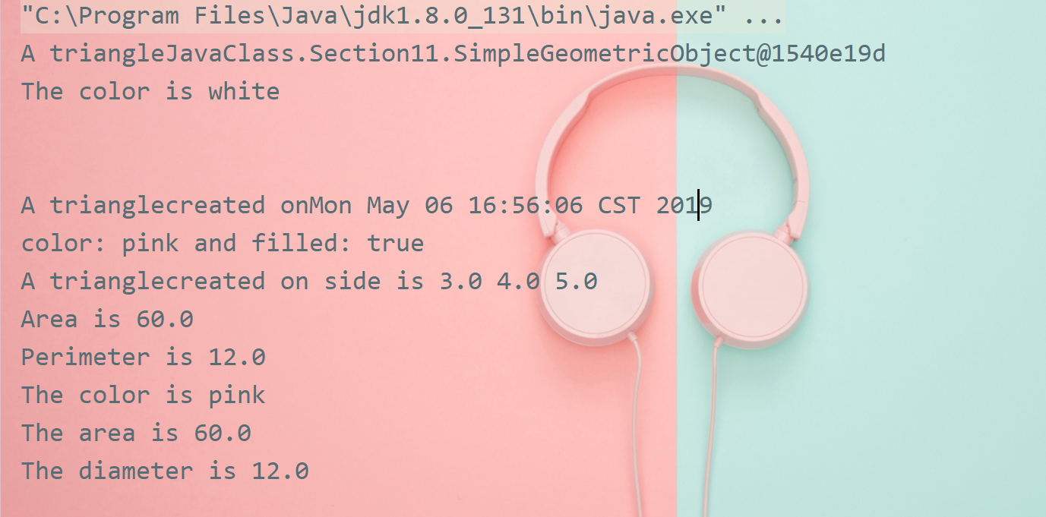

**// 11.2**

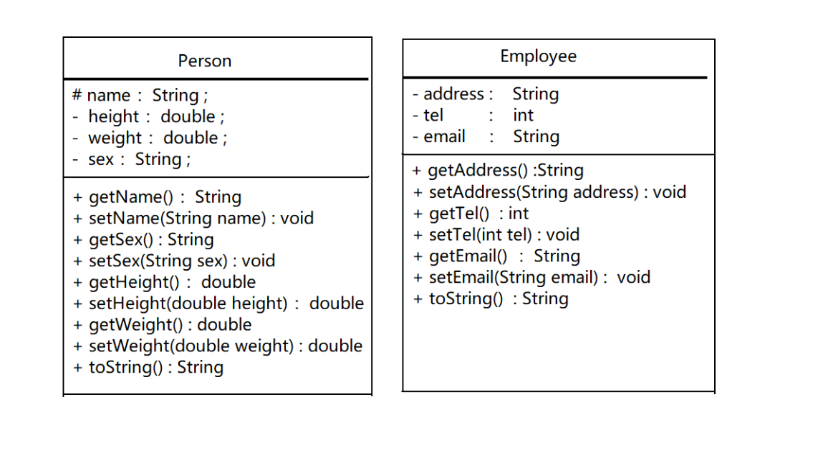

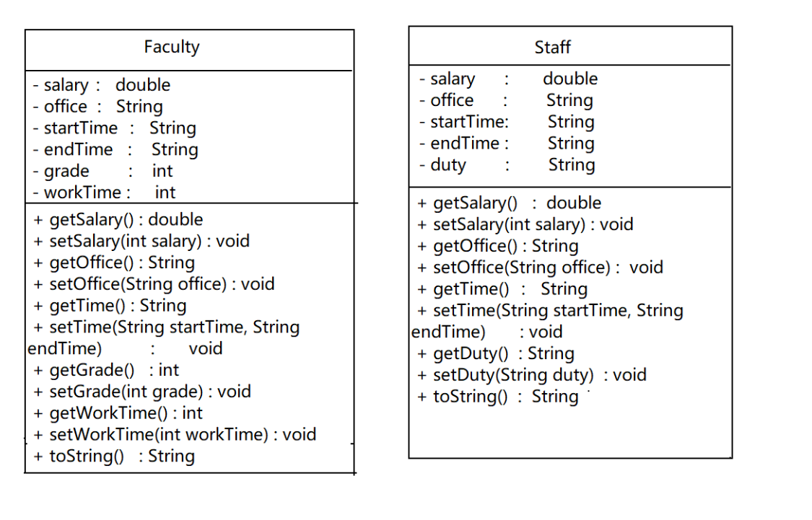

**package JavaClass.Section11**;  
  
**public class PersonCollection** *{* **public static void** main*(***String** agrs*[]) {* **Staff** staff = **new** Staff*()*;  
 **System**.***out***.println*(*staff.toString*())*;  
 *}  
}***class Person** *{* **protected String** name;  
 **private double** height;  
 **private double** weight;  
 **private String** sex;  
  
 **public** Person*(){* name = "default";  
 height = weight = 0;  
 sex = "female";  
 *}* **public** Person*(***String** name, **double** height, **double** weight, **String** sex*){* **this**.name = name;  
 **this**.height = height;  
 **this**.weight = weight;  
 **this**.sex = sex;  
 *}* **public String** getName*(){* **return** name;  
 *}* **public void** setName*(***String** name*){* **this**.name = name;  
 *}* **public String** getSex*(){* **return** sex;  
 *}* **public void** setSex*(***String** sex*){* **this**.sex = sex;  
 *}* **public double** getHeight*(){* **return** height;  
 *}* **public void** setHeight*(***double** height*){* **this**.height = height;  
 *}* **public double** getWeight*(){* **return** weight;  
 *}* **public void** setWeight*(***double** weight*){* **this**.weight = weight;  
 *}* **public String** toString*(){* **return** "Name: " + name + "\nSex: " + sex + "\nHeight: " + height + "\nWeight: " + weight;  
 *}  
}***class Student extends Person***{* **public static int** *ONE* = 1;  
 **public static int** *TWO* = 2;  
 **public static int** *THREE* = 3;  
 **public static int** *FOUR* = 4;  
  
 **private int** grade = 0;  
  
 **public** Student*(){* **super***()*;  
 grade = 0;  
 *}* **public** Student*(***String** name, **double** height, **double** weight, **String** sex, **int** grade*){* **super***(*name,height,weight,sex*)*;  
 **this**.grade = grade;  
 *}* **public int** getGrade*(){* **return** grade;  
 *}* **public void** setGrade*(***int** grade*){* **this**.grade = grade;  
 *}  
  
 @Override* **public String** toString*(){* **return super**.toString*()* + "\nGrade: " + grade;  
 *}  
}***class Employee extends Person***{* **private String** address;  
 **private int** tel;  
 **private String** email;  
  
 **public** Employee*(){* **super***()*;  
 address = "default";  
 tel = 0;  
 email = "default";  
 *}* **public** Employee*(***String** name,**double** height, **double** weight, **String** sex,  
 **String** address, **int** tel, **String** email*){* **super***(*name,height,weight,sex*)*;  
 **this**.address = address;  
 **this**.tel = tel;  
 **this**.email = email;  
 *}* **public String** getAddress*(){* **return** address;  
 *}* **public void** setAddress*(***String** address*){* **this**.address = address;  
 *}* **public int** getTel*(){* **return** tel;  
 *}* **public void** setTel*(***int** tel*){* **this**.tel = tel;  
 *}* **public String** getEmail*(){* **return** email;  
 *}* **public void** setEmail*(***String** email*){* **this**.email = email;  
 *}  
  
 @Override* **public String** toString*(){* **return super**.toString*()* + "\nAddreaa: " + address +  
 "\nTel: " + tel + "\nEmail: " + email;  
 *}  
}***class Faculty extends Employee***{* **private double** salary;  
 **private String** office;  
 **private String** startTime;  
 **private String** endTime;  
 **private int** grade;  
 **private int** workTime;  
  
 **public** Faculty*(){* **super***()*;  
 salary = 0;  
 office = "default";  
 startTime = "timeless";  
 endTime = "timeless";  
 grade = 0;  
 workTime = 0;  
 *}* **public** Faculty*(***String** name,**double** height, **double** weight, **String** sex,  
 **String** address, **int** tel, **String** email, **double** salary, **String** office,  
 **String** startTime, **String** endTime, **int** grade, **int** workTime*){* **super***(*name,height,weight,sex,address,tel,email*)*;  
 **this**.salary = salary;  
 **this**.office = office;  
 **this**.startTime = startTime;  
 **this**.endTime = endTime;  
 **this**.grade = grade;  
 **this**.workTime = workTime;  
 *}* **public double** getSalary*(){* **return** salary;  
 *}* **public void** setSalary*(***int** salary*){* **this**.salary = salary;  
 *}* **public String** getOffice*(){* **return** office;  
 *}* **public void** setOffice*(***String** office*){* **this**.office = office;  
 *}* **public String** getTime*(){* **return** startTime + "-" + endTime;  
 *}* **public void** setTime*(***String** startTime, **String** endTime*){* **this**.startTime = startTime;  
 **this**.endTime = endTime;  
 *}* **public int** getGrade*(){* **return** grade;  
 *}* **public void** setGrade*(***int** grade*){* **this**.grade = grade;  
 *}* **public int** getWorkTime*(){* **return** workTime;  
 *}* **public void** setWorkTime*(***int** workTime*){* **this**.workTime = workTime;  
 *}  
  
 @Override* **public String** toString*() {* **return super**.toString*()* + "\nSalary: " + salary + "\nOffice: " + office +  
 "\nTime: " + startTime + "-" + endTime + "\nGrade: " + grade + "\nWorkTime: " + workTime;  
 *}  
  
}***class Staff extends Employee** *{* **private double** salary;  
 **private String** office;  
 **private String** startTime;  
 **private String** endTime;  
 **private String** duty;  
  
 **public** Staff*() {* **super***()*;  
 salary = 0;  
 office = "default";  
 startTime = "timeless";  
 endTime = "timeless";  
 duty = "default";  
 *}* **public** Staff*(***String** name,**double** height, **double** weight, **String** sex,  
 **String** address, **int** tel, **String** email, **double** salary, **String** office,  
 **String** startTime, **String** endTime, **String** duty*){* **super***(*name,height,weight,sex,address,tel,email*)*;  
 **this**.salary = salary;  
 **this**.office = office;  
 **this**.startTime = startTime;  
 **this**.endTime = endTime;  
 **this**.duty = duty;  
 *}* **public double** getSalary*(){* **return** salary;  
 *}* **public void** setSalary*(***int** salary*){* **this**.salary = salary;  
 *}* **public String** getOffice*(){* **return** office;  
 *}* **public void** setOffice*(***String** office*){* **this**.office = office;  
 *}* **public String** getTime*(){* **return** startTime + "-" + endTime;  
 *}* **public void** setTime*(***String** startTime, **String** endTime*){* **this**.startTime = startTime;  
 **this**.endTime = endTime;  
 *}* **public String** getDuty*(){* **return** duty;  
 *}* **public void** setDuty*(***String** duty*){* **this**.duty = duty;  
 *}  
  
 @Override* **public String** toString*(){* **return super**.toString*()* + "\nSalary: " + salary + "\nOffice: " + office +  
 "\nTime: " + startTime + "-" + endTime + "\nDuty: " + duty;  
 *}  
}*

*//运行结果*

